Public Participation Vs Institutional Conservation: a dichotomy surrounding the art object
Introduction
This essay is an attempt to discuss the dichotomy that seems to exist between the gallery's view of the object and experimental art, which is based on life experience and public participation, taking as an example Hélio Oiticica’s art work “B 11 Box Bólide 09 1964” that is part of the Tate Modern Collection.
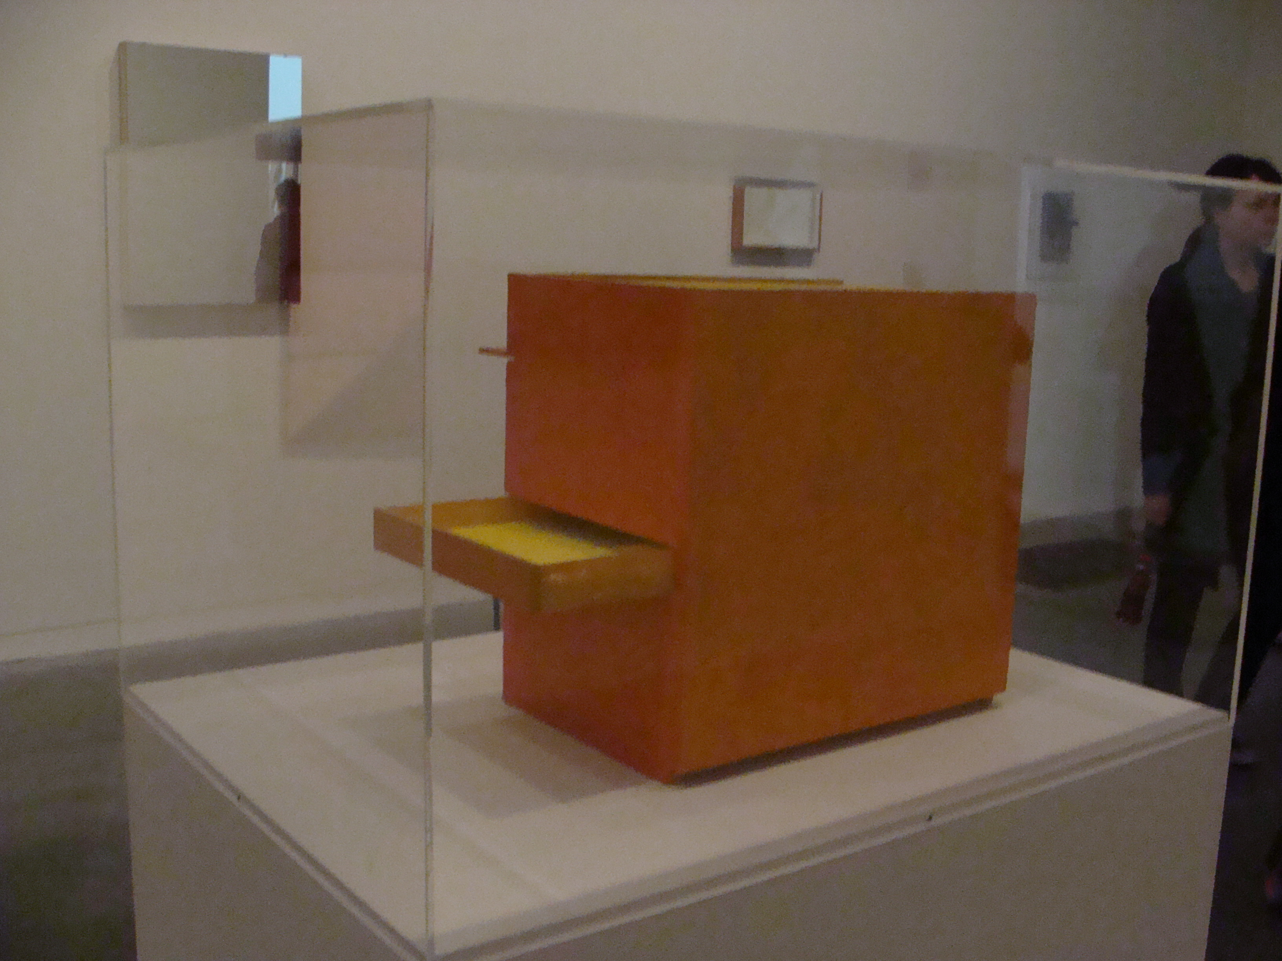
B11 Box Bólide 09 1964 at Tate Modern (Photo: Duailibe)
This idea of writing about the art object and the position it now occupies: between its conservation and the artist original intention of public participation occurred when I first saw Oiticica’s work Bólide, created to be handled by the public, enclosed in a crystal coffin at Tate Modern.
Firstly, I will talk about Oiticica’s context; the ‘vivência’ or life experience (lost in translation) movement; the Bólides and public participation; his ideas about the ‘creleisure’ of the art object; the Parangolés and a conception of anti-art and ‘Tropicália’; a Brazilian identity depicted by him.
Contemplating the other side of the dichotomy, in part two, I will discuss the museum and its conservative view; the museum's identity and how its logic is put in such a normalized way that shapes our bodies and our perception of art. In the course of this analyse I will have an encounter with Foucault’s theory of normalization, discourse and identity.
In part three, I will attempt to argue whether there are ways in which active public participation with this particular art work could be interactive inside the gallery. Furthermore, how the experience of public participation would be educational in generating a different conception of institution.
Hélio Oiticica: The revolutionary anti-artist
Perhaps ‘revolutionary’ is the word that most define Hélio Oiticica’s work and his vision about art. Transgressing the traditional concept of art and the art object, he proposed an experimental attitude in art made by the relation between the artist and the public. The art object is not seen anymore as the ending or result of the creative process; rather, it is the beginning: the way to provide an act of collective participation in the direction of the transformation of society.
However, before I continue to discuss Oiticica’s aesthetic conceptions, it is worth describing his context. He was born in Brazil in 1937, as his father was against the educational system; he studied with his mother in Rio de Janeiro until he was 10 years old. Then, he went to Washington where he studied until 1950. Returning to Brazil, in 1954, he started his art studies with Ivan Serpa in the Modern Art Museum of Rio de Janeiro. In 1956 he began to paint Secos, gouaches on cardboard and Metaesquemas, paintings in which the composition was based on the concept of gestalt and the ideas of concrete art; those works lead him to participate in the 1st Exposition of Concrete Art in1956/57 in Rio de Janeiro and Sao Paulo.
In 1959 Oiticica founded, with Lygia Clark, Almicar de Castro and Franz Weismann, the Neo-concrete group breaking with the concrete aesthetic. In that moment, his work began to consider the body having a direct interaction with the art object, contesting the contemplative attitude of the spectator. Underpinned by Merleau-Ponty’s idea of perception, that we perceive the world with our all body, he questioned the classical western notion of art established on the pure contemplation of the viewer, which only relies on the realm of the gaze. Now, the public is invited to explore the other senses of the body. According to Hélio Oiticica, the aesthetic experience needs to pass from the visual field to the others senses like touch, smell, taste and hearing. Therefore, it is necessary that we have this ‘consciousness of the totality’, of the relationship between the individual and the world as a whole action. In ‘The Senses Pointing towards a New Transformation’, he says that:
“All senses relations are established in a human context as a ‘body’ of significations and not a sum of signification apprehended by a specific channel”. (Oiticica, 1969, pg.1)
Furthermore, Oiticica completely denied the notion of a bi-dimensional artwork posed in a framing or bounded in the object. With colour invading the environment, he created Spatial Relief and Nuclei, a series of canvas painted on both sides and installed on the environment where the public could walk and pass through them. The experience of the artwork is described by Alvarado and Guerra as:
“It was walking between the colour, in a dynamic and spatial vision of the colour” (Alvarado and Guerra, MAC - USP). |Trans. Duailibe|

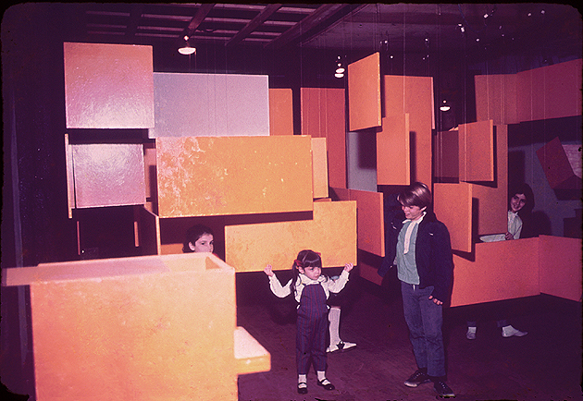
Nuclei (Programa Helio Oiticia)

Having this sense of the importance of the all body in the perception of art, in 1962, Oiticica began to produce a series of ‘Bólides’, that in Portuguese means fireball, which were containers, glasses, boxes, mostly made from materials found in the street. Inside the Bólides colour appears, as Guerra mentioned, in the ‘state of pure essence’ (Guerra, MAC-USP). They were intended to be handled by the viewer, where senses such as touch and smell are explored. Oiticica said that the Bólides were the egg, the beginning of something much bigger. Katz affirms that:
“Here the revolution began in earnest... He was now willing to let real life take an active role in his work, not in the sense of found object, but in a deliberate attempt to create art that exists on an equal plane to life and can suggest direct interaction with it. The Bólides ...not only are they non-formal, they are also approaching Oiticica’s idea of anti-art”. (Katz, 2007, pg.79)
It is important to consider that what Oiticica proposed with his Bólides was beyond simple participation. Based on the idea of the Brazilian critic Mário Pedrosa that “Art is the experimental exercise of freedom”; he proposed the idea of art as a process of collective manifestation, denying the notion of object, authorship and aesthetic. What is prominent in this concept is that the primacy no longer resides in the object itself, but in the process, the exercise. Ramme points out:
“The focus of this concept it is not the work as finished object, but the process, better saying, the exercise, the experience of creation or invention – or as Hélio repeats several times: ‘To experiment the experimental’. Therefore, the art would be the practical and existential exercise of freedom, without restrictions or limits to the ways that the exercise would give”. (Ramme, pg. 472) |Trans. Duailibe|
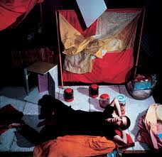
Oiticica and the Bolides (Projeto Hélio Oiticica)
The result is the living experience as a creative process and the idea of transgression and surpassing classical values attributed to the art object. This idea is linked by Oiticica to behavioural change and to the expansion of individual consciousness. Thus for one to have ‘consciousness of the totality’ it is necessary that one changes his/her traditional forms of behaviour into what he named ‘crebehaviour’, the creative behaviour. Oiticica proposes this solution to resolve conflicts between the subject and the object. The ‘crebehaviour’ is also grounded in his idea of ‘creleisure’, the non-repressive leisure; the creative leisure which is also spontaneous, without the necessity of thinking, as he states:
“Once the “distances” between ideal aesthetic goals are abolished or transformed into the crebehaviour, into the continuous consciousness of a living process, the conflicts tend to be solved or assume higher levels; in my evolution I arrived at what I call creleisure… as direct consequence of this absorption of art-process into life-process. Creleisure is the non-repressive leisure, opposed to diverted oppressive leisure thinking; a new unconditioned way to battle oppressive systematic ways of life. It is practice, open-practice.”(Oiticica, 1969, pg.3)
As an example of creleisure, in the Bólides, the pleasure of touch, the ‘essence’ of colour, it is just for the act of living that experience, or what, in Portuguese, he called vivência, the life process of feeling. Creleisure is, for him, the simple and creative pleasure, with no ending or results of that experience, without trying to understand why, what or how. It is that moment when you let your body have the sensation of colour, as he explained:
“In the Bólides, you would have to wear gloves and cave into the earth; just for the pleasure of touching around the earth...I want the creleisure to be a revealing moment... the continuous pleasure related directly to the open-free-minded state of sensorial contacting, in a kind of awakening up sensorial feelings activity”. (Oiticica, 1968, pg.2)
This statement proposed by Oiticica highlights a continuous revolution in contemporary practice, as example, when we started having lessons at Tate Modern, as part of the Contemporary Art, Identity and Education module of the MA in Artist Teachers and Contemporary Practices at Goldsmiths, we discussed the comprehension of an art object, in consideration of the artist’s statement and the curator’s explanation. At that time, some of us spoke about the necessity of apprehension, how we would like to understand and reveal the artist’s intention, why he made something in this way, why he didn’t make it that way, why he used that kind of materials, why he gave it that name and why he gave it that form. Why? What is the reason for that? Sometimes we are just apprehensive in knowing and understanding the art object mainly through cognitive process whist inhibiting the totality of the consciousness, having this necessity to absorb it through our minds. Mostly, this understanding is given ‘a priori’, framed by the curator or the institution’s view.
What Hélio Oiticica proposed in his ideas and thoughts about art is more than the understanding of the hermeneutic aspects of his work; it is in the experiencing of it, feeling it, living it. He also suggested more than public participation, it was, as previously mentioned, behaviour changing. Oiticica said in an interview with Guy Brett that what you take out of the work ‘Eden’ (an environmental art installation) depends on what you bring to it. He was developing the idea of art as a collective and participative model of thinking and acting. Moreover, art should promote the engagement of the public in their artistic, cultural and social space. According to him:
“The idea of creating such relations is more than a simple participation as a manipulation of objects: there is a search for what we could call a biological ritual, where the interpersonal relations would enrich each other and establish a really growing communication on an open level” (Oiticica, 1969, pg 5)
This complete change of the relationships between subject-object in art by Oiticica was in part inspired by the Brazilian graphic designer Rogério Duarte and his idea of ‘probject’: the conception that the object is an open structure, created by participation, infinite in possibilities, as he pointed out:
“The object is a probability, not the result of one probability, but the potentiality for a probability that can be many – here the probability is a collective term that can turn out into many things.” (Oiticica, 1968, pg. 1)
Thus, with the idea of probject, Oiticica intends that the art work somehow goes beyond the object, where the aesthetic experience needs to leave the mere contemplative field to a new level of participation: the art going beyond the sacred to the quotidian life. As he affirms: “It is not seeing the art as a supreme object, untouchable, but as a creation for life”. This conception also leads him to the notion of anti-art, contrary to the classical western ideas of art. Ann Gallagher the curator who wrote about the Hélio Oiticica Exhibition at Tate Modern in 2007 added that:
“He challenged the traditional boundaries of art, and its relationship with life, and undermined the separation of the art-object from the viewer, whom he turned into an active participant”. (Ann Gallagher, 2007, Tate Modern)
However, it is important to note that the kind of participation which Oiticica disseminates here differs from the conventional model of museums or galleries, the audience and exhibitions. Furthermore, he relinquishes the audience from the artist’s conceit and invites the public to collaborate with his ideas. The participation here is active, open and free. The work is proposed to the participators with the idea of expanding their consciousness, for them to have creleisure and to find their internal liberty. In his writing ‘Appearance of the Supra-Sensorial he elucidated that:
“The object was a passage to experiences increasingly engaged with the individual behaviour of each spectator: I must insist that the search, here, is not for a new conditioning of the participator, but an overturning of every conditioning in the quest for individual liberty, through increasingly open propositions, aimed at making each person find within themselves, through accessibility, through improvisation, their internal liberty, the path for a creative state”. (Oiticica, 1967, in 2000 pg. 266)
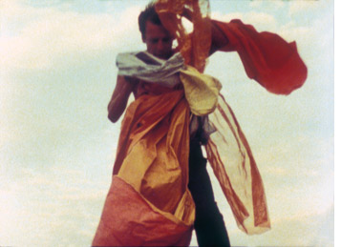
Hélio Oiticica with P4 Parangolé, Cape 1, 1964 (Ivan Cardoso)
If in the Bólides, Oiticica refuted the classical conceit of art, affirming himself as an anti-artist, with the Parangolés, he reached the peak of challenging the traditional idea of art. The Parangolés were a kind of cape or standard, made by fabrics, paints, plastics and ropes. Most of the time having something written on them, only showing their full nature when inhabited by the spectator, thus, the Parangolés, as Antonio Cícero cited, were not to be seen but touched; they were not to be touched but worn (Cícero, 1995), they were not just to be touched and worn but performed. Oiticica made his first Parangolé, in 1964, when he lived in Mangueira favela, in Rio de Janeiro, when Brazil was under a dictatorial regime. With the Parangolés he gave body to colour and to the body the sensation of wearing, dancing and playing with colour, enabling creleisure, having the consciousness of the totality, revealing itself.
Oiticica referred to the Parangolés as “anti-art par excellence” (Oiticica, 1986). Thus they are not categorized as sculptures or paintings and they are just fulfilled when the spectator becomes, with the object, part of the artwork. They are life sculpture, that dance and, approximate art and life, making art as extension of being.
During the exhibition ‘Opinion’ in the Modern Art Museum in Rio de Janeiro, in 1965, he brought people from the favela wearing and fulfilling the Parangolés. In that time it was necessary to wear a suit and tie to come into a museum (Guerra, MAC – USP). Oiticica and his friends were expelled from the museum, from his own exhibition. Then they continued to perform on the front garden of the museum. Although he, as a visionary, tried to promote this encounter between the popular art and the classical, his ideas were too revolutionary for his time.
After the revolution of the Parangolés, continuing to pursue life experience and crebehaviour by the spectator, Oiticica now concentrated his efforts in producing art installations and environmental art. Creating environments, where the public could enter into and have several tactile-sensorial stimuli. In one of those installations, Tropicália, he portrayed a ‘Brazilian Identity’. With Tropicália he showed the myth of ‘Tropicalism’ stereotyped by the western culture. As he pointed out:
“I believe that Tropicália, which encompasses this entire series of propositions, came to contribute strongly to this objectification of a total “Brazilian” image, to the downfall of the Universalist myth of Brazilian culture, entirely based on Europe and North America and on an Aryanism which is inadmissible here”. (Oiticica, 1968 in 2000, pg.262)
Despite the idea that Brazil is a tropical country, with lots of beaches, plants, parrots and banana trees, Tropicália represents more than that. Inspired by the architecture of the favela, on one of the installation’s wall it has the sentence: ‘The purity is a myth’. Oiticica wanted to break with all the norms and rules; transgressing the established structures; contesting all types of conformism. Thus, he depicted a revolutionary attitude in the Brazilian society. According to him:
“The myth of "tropicality" is much more than parrots and banana trees: it is the consciousness of not being conditioned by established structures, hence highly revolutionary in its entirety. Any conformity, be it intellectual, social, or existential, is contrary to its principal idea.” (Oiticica, 1968 in 2000, pg.263)
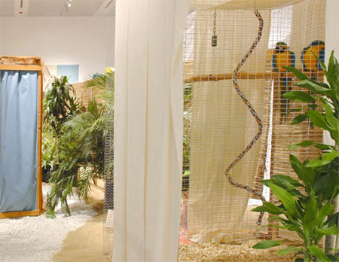
Tropicália (Programa Hélio Oiticica)

The revolution in art proposed by Oiticica affected the museums. As an anti-artist par excellence he also challenged, with his works and his ideas, the museum’s practice of displaying things, as he stated that:

“The impossibility of “exhibiting” objects as part of this idea, in galleries or museums, has become evident…The Exhibition room refers always to an old idea of “displaying objects”, to an “objectal representation”; so, why insist on the old form when a new experimental world demands, and with urgency, complete new ways of communication.” (Oiticica, 1969, pg.4)

Furthermore, according to Osthoff, the works of contemporary artists as Hélio Oiticica and Lygia Clark continue to resist being frozen or conserved in museum displays, challenging the traditional notion of the art object and the artistic institution.

“Clark's and Oiticica's creations, as they changed the traditional role of the viewer and the status of the artistic object, confronting in the process the function of artistic institutions, redefined the identity of the artist and the idea of authorship. Emphasizing viewer participation and material precariousness, their works continue to resist being frozen in museum displays as relics of past actions”. (Osthoff, 2004)

However, there still remains the question of how to exhibit contemporary artists such as Clark and Oiticica inside institutions like museums and galleries?
Museum’s Paradigm: Conservation or Participation?
“A museum is an institution that cares for a collection of artefacts and other objects of scientific, artistic, cultural, or historical importance and makes them available for public viewing through exhibitions that may be permanent or temporary”.(Alexander and Potter, 2008)
In the above definition of museums, Alexander and Potter describe museums as institutions that make objects available for the public viewing. Searching for the definition of institution in Sanford Encyclopaedia of Philosophy, it says that:
“An institution is any structure or mechanism of social order and cooperation governing the behaviour of a set of individuals within a given human community. Institutions are identified with a social propose and permanence, transcending individual human lives and intention by enforcing rules that governs cooperative human behaviour”. (My emphasis)
This notion that institutions rule and govern human behaviour is well exemplified by Foucault, who considers that they are mechanisms which normalise our behaviour and judgment of the world. According to Dennis Atkinson:
“Thus particular institutions mobilise particular forms of visuality to see, order, regulate and normalise the social world”. (Atkinson, Vision and Visuality)
Paul Oliver comments that Foucault was interested in the power and influence that institutions exerted in our lives, “and also in the fact that some people simply could not avail themselves of the services provided by institutions because they could not understand the systems within which they operated. In such cases institutions can deprive people of their personal freedom and autonomy. In circumstances where individual citizens cannot successfully interact with institutions, then they can easily become alienated from them, and moreover alienated from society in general”. (Oliver, 2010)
The system of normalisation made by the institutions is proposed in such ideological discourse and practice that norms usually are not questioned, they are just obeyed, and we feel that they are natural as if they always have been there. However, as Atkinson infers: “What such norms do not question is the norm itself and how it is constituted within its specific focus of practice”. (Atkinson, 2002, pg.99)
The institutional discourse shapes our practice, and our vision of the world. For example, inside the museums there are norms which we do not speak or laugh loudly, we cannot eat or drink, we cannot touch and we do not go mad, dance, sing or make love (McEvilley, T. 1999, pg.10). So, we must be completely quiet and composed, as O’Doherty highlighted, we must be a “Spectator with a disembodied eye”:
“A gallery is constructed along laws as rigorous as those for building a medieval church. The outside world must not come in...The space offers the thought that while eyes and minds are welcome, space-occupying bodies are not”. (O’Doherty, 1999, pg.15)
Thus, it seems that there are a certain kinds of alienation resulting from these norms and rules that exist in museums and galleries, caused by their discursive practice and lack of public participation. Usually, when we visit a museum or a gallery, we also leave our autonomy outside, we are there as passive spectator and our participation is restricted to being enlightened by what we see, without power to change anything, or even questioning the institution’s control.
Elaine Heumann Gurian describes that part of this process of alienation rests on assumptions that museums and galleries have from their public: “We, consciously or unconsciously impose learning impediments in our exhibitions for some members of our current and potential audiences. We do so because we posses unexamined beliefs about our visitors’ capacity to learn and because we want them to act in a style that reinforces our notion of appropriate audience behaviour”. (Gurian, 1991, pg. 176)
One reason why museums and galleries have norms, which regulate our behaviour, making us, as O’Dorethy mentioned, an eye without a body, is due to the value given to the art object. For example, the Mona Lisa of Leonardo da Vinci, considered one of the most expensive paintings in the world, was valued in US$743 million in 2011. Perhaps that is also the reason why the Louvre is the most visited museum in the world, although recent research has showed that the time spent in seeing the painting is no more than three minutes. Just enough time to take a short snap with your camera, if you are lucky enough to get yourself close to it.
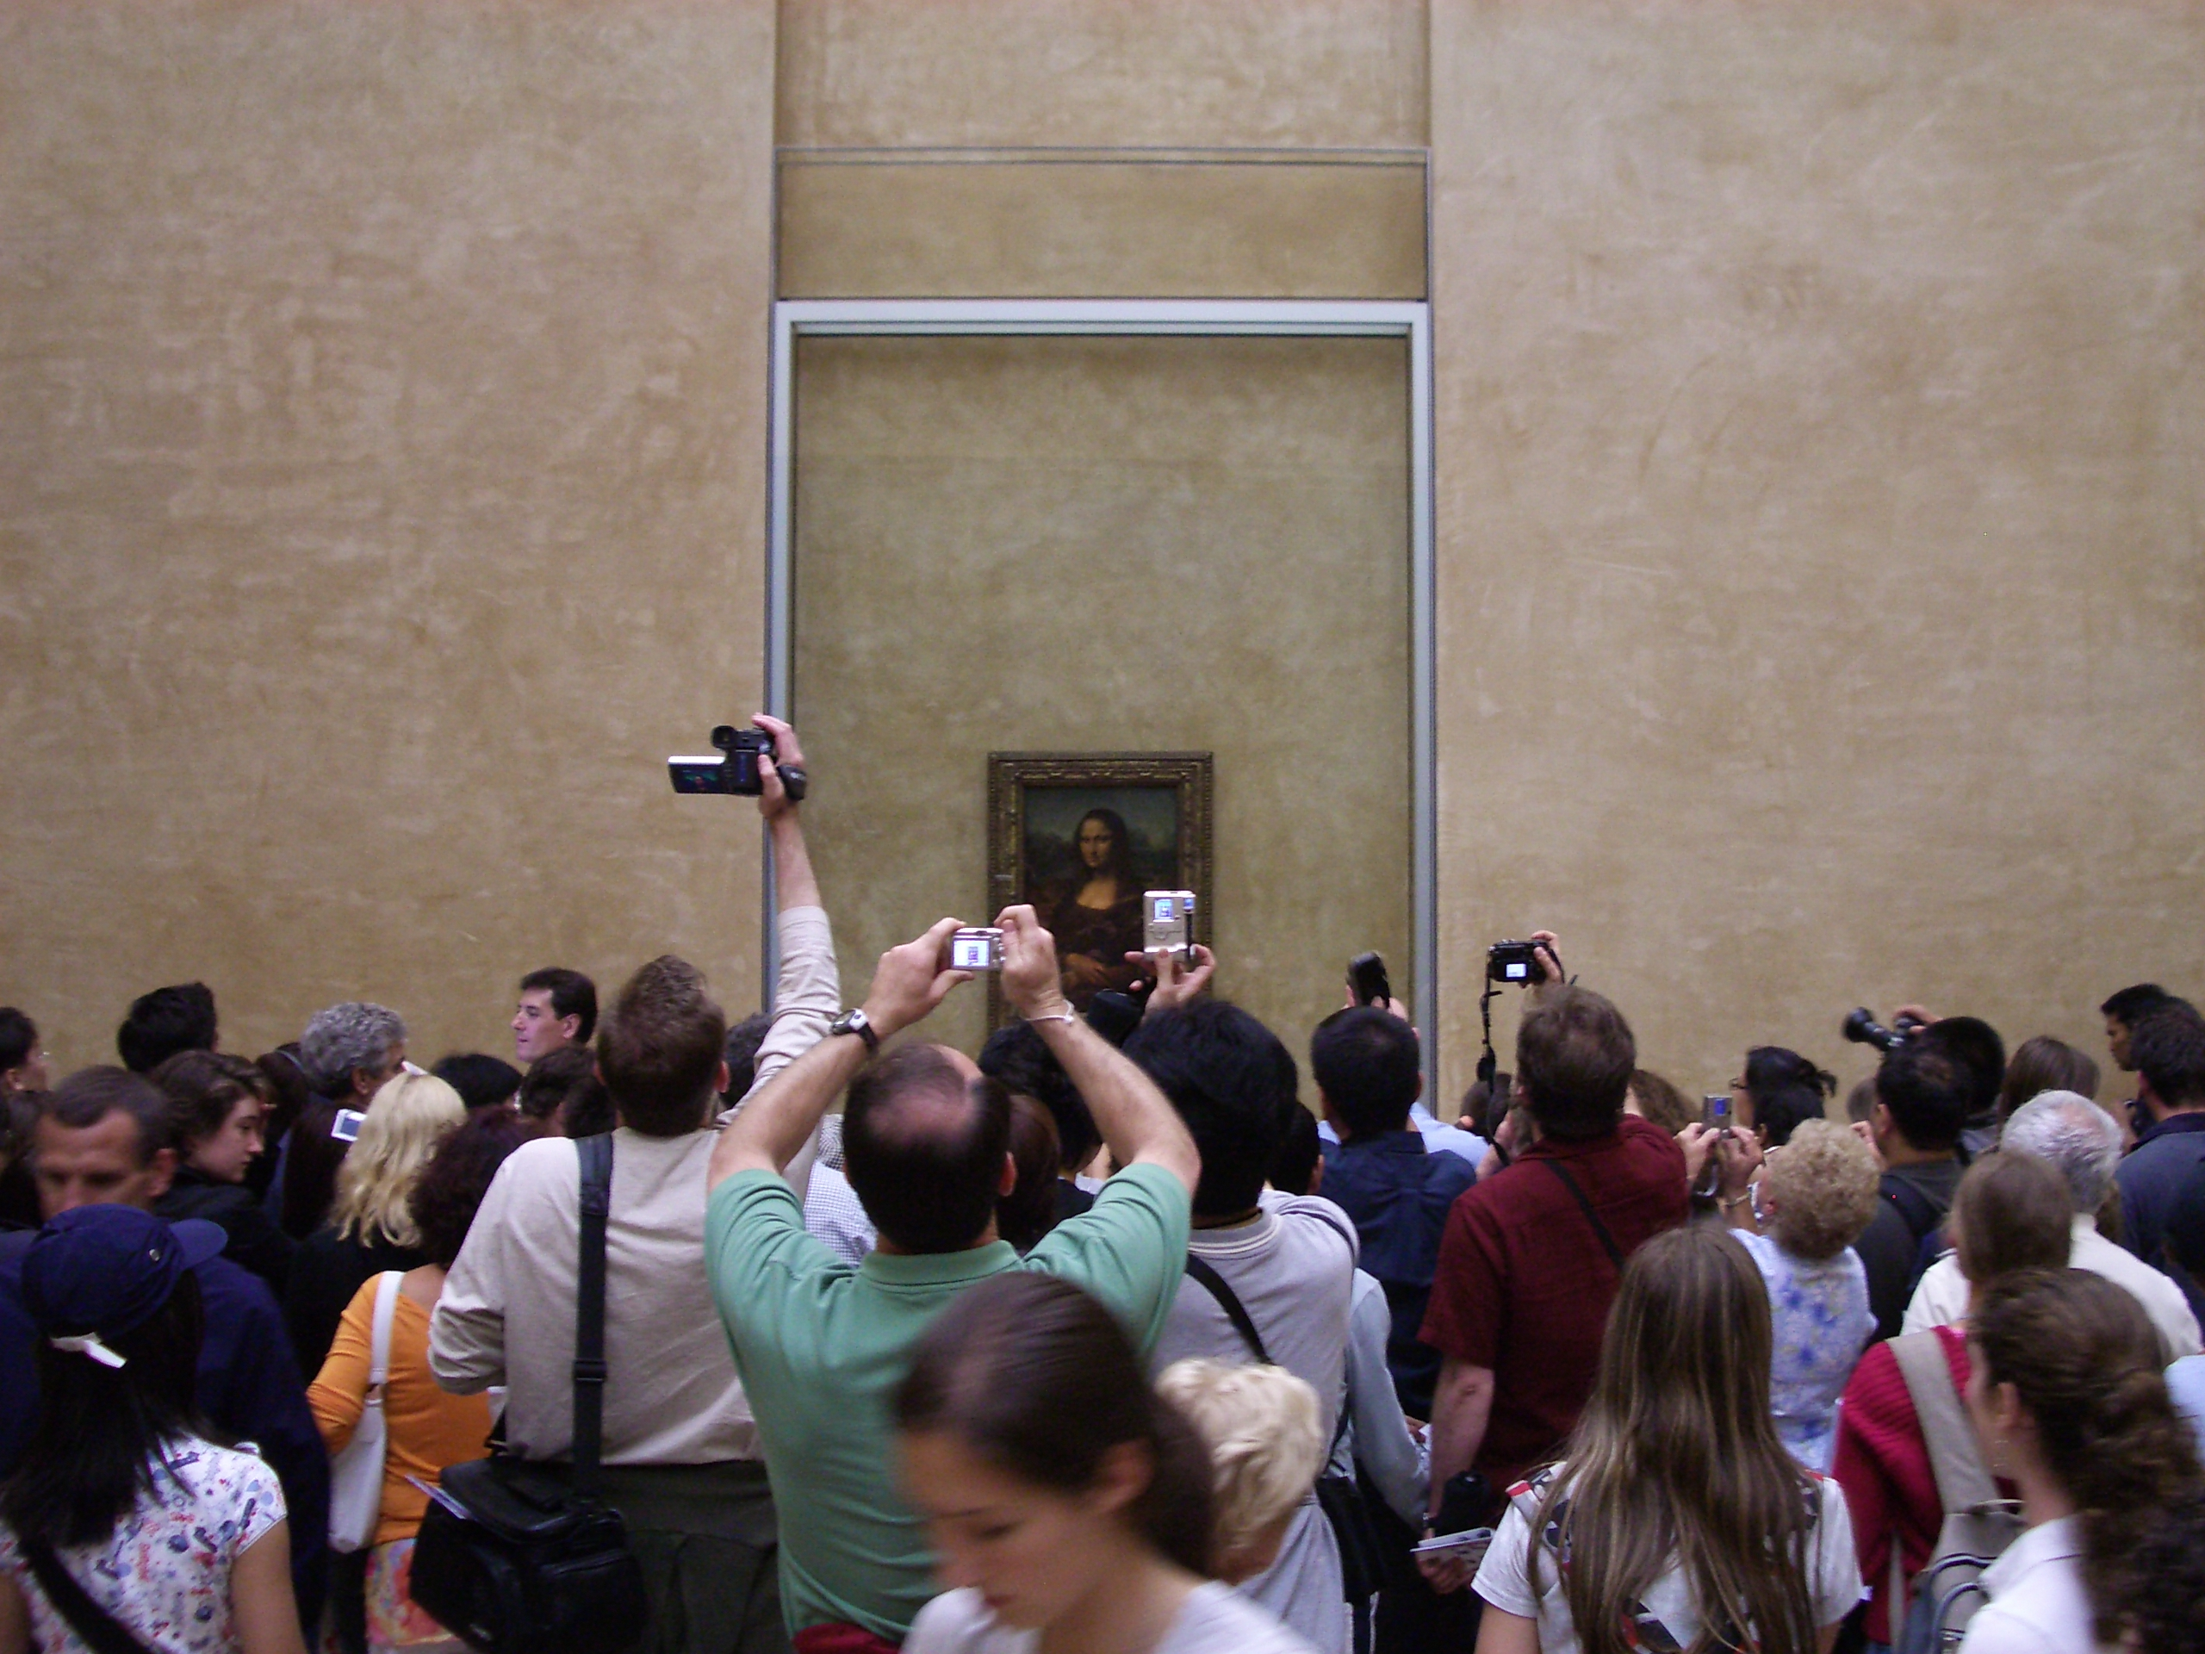
As a consequence arising from the value of the art object, there is the necessity of conservation, so museums and galleries must preserve and conserve their collection of objects and making them as eternal as they can. Oiticica challenged this notion of eternity of the art object, and with his art work “B 11 Box Bólide 09 1964”, which is confined in a crystal box at Tate Gallery, he proposed participation instead of conservation. The principal idea of that work is for the public to experience creleisure, playing with the coloured pigment inside of the box.
When I first saw the Bólide enclosed in that crystal coffin, several questions came to my mind: why do we have the necessity to immortalise things? Why do we value objects more than the experience? Is that part of exhibiting the past? Oiticica died in 1980 and, unfortunately, part of his works was destroyed in an accidental fire in 2009. So, what Tate has with the Bólide is the “trace” of a period that could never return. Therefore, there is the necessity to show the future generation what Oiticica was about. Thus, the gallery must conserve that piece, so no one can have access, avoiding the possibility of destroying it. However, was that the artist’s intention? Or could we say that the box enclosure in a coffin, without any meaning, is an art object? Is it dead? Furthermore, with the Bólide confined in that way is Tate showing or, better saying, educating people about Oiticica’s art works? What we can affirm for sure is that the curatorial restriction in the mode of display, the object becomes severed from the public in a way that the artist did not intend.
The dilemma found in how to preserve works of contemporary artists like Hélio Oiticica, Lygia Clark, and Noritoshi Hirakawa is far of being solved. Oiticica’s work is preserved internationally, in museums like the Museum of Modern Art in New York, as well as other American museums and institutions in England and Spain. However, Christina Roiter, describes that:
“None of this takes into account the significance of the demise of the physical works of art of a conceptual artist whose work was not so much about particular objects as the physical deployment of objects in space through spectatorial interaction. According to Brazilian poet and writer Ferreira Gullar, “They treated Hélio as if he was a Renaissance artist, when he was actually a creator of concepts, propositions, interventions, an artist of the future, not of a neo-concrete past that stayed behind, reducing the dimension of one of the inventors of contemporary art.
Can the work of an experimental artist who made installations, performances, and videos really be said to be lost when the work was always intended to be based in action significant at the time of the event, and whose value resides in what it represented at that moment in the 70s?” (Roiter, 2010)

It is time for a new notion of institution to take the place, being, above of all, educational.

The Educational Institution: Dialogue and Participation
Taking into consideration the work of Paula Findlen: "The Museum: its classical etymology and renaissance genealogy", it shows us the other face of museums, sometimes hidden and forgotten, its educational side. Having a close look in the etymology of the world “museum” she points that:
“The English "museum" comes from the Latin word, and is pluralized as "museums" (or rarely, "musea"). It is originally from the Greek Μουσεῖον (Mouseion), which denotes a place or temple dedicated to the Muses (the patron divinities in Greek mythology of the arts), and hence a building set apart for study and the arts”. (Findlen, 1989)
Nevertheless, it has been demonstrated before, museums have false beliefs in the learning capacity of their public, sometimes due to the behaviour control of the institution, sometimes due to the lack of educational programmes that take into consideration the viewer playing an important role as a co-elaborator. Gurian also explains why gallery display cannot explore sensory possibilities because its focus is on the visual sense and they rarely use auditory, olfactory or tactile techniques or even want to appeal to the emotions or appear to be enthusiastic or friendly. As she explains:
“Nor do we want to appear friendly, because we believe that informality would reduce the importance of our work. If the audience is having fun, we may be accused of providing a circus and not behaving in a sufficiently reverential manner. If we have a Calvinistic view of our purpose, we will not permit ourselves to be informal. But if we as exhibition producers begin to think that playfulness is a permissible part of learning, different exhibition strategies may take over”. (Gurian, 1991, pg.183)
When we understand that education is dialogue, and as dialogue it is conversation, an exchange of ideas, thoughts, feelings, emotions (Freire, 1986, 1992) it is necessary that we create space for questioning (Faundez and Freire, 1989). So, it is also important to consider that during the questioning process there are no wrong or right questions to be made, whereas there are no wrong or right answers to be given. Thus, in creating an open space where everyone has the freedom to ask and answer questions we have accomplished our practice of educating, and asking questions, taking risks, making mistakes so that we can advance our knowledge (Faundez in Faundez and Freire, 1989, p.41).
So, it is the time for the museums to explore their educational side, and promote a dialogue with their visitors, giving them body, voice and autonomy. Nina Simon, in her book “The Participatory Museum”, looks at ways in how museums can promote a participatory experience with their public to enable people to be creators, collaborators, curators, critics, designers, whoever they want to be. As result of that we have an educational space that really offers learning experience. She demonstrates that:
“When it comes to developing participatory experiences in which visitors create, share, and connect with each other around content the same design thinking applies. The chief difference between traditional and participatory design techniques is the way that information flows between institutions and users. In traditional exhibits and programs, the institution provides content for visitors to consume. Designers focus on making the content consistent and high quality, so that every visitor, regardless of her background or interests, receives a reliably good experience.
In contrast, in participatory projects, the institution supports multi-directional content experiences. The institution serves as a “platform” that connects different users who act as content creators, distributors, consumers, critics, and collaborators. This means the institution cannot guarantee the consistency of visitor experiences. Instead, the institution provides opportunities for diverse visitor co-produced experiences”. (Simon, 2010, chapter 1)
Close investigation of these two definitions of museums, and taking into consideration Hélio Oiticica’s ‘B 11 Box Bólide 09 1964’ and the way which Tate Gallery is showing it to the public, it seems there is a dichotomy surrounding the art object within the museum’s identity. If on one side we have the necessity to care and preserve the art object, on the other, we have what was the artist’s intention of creleisure and the proposal to educate and provide for the public the consciousness of the totality. Again, what Oiticica intended with his work is provoking an act of collective participation that could result in behaviour changing and society transformation. Therefore, which answers we could have for the question of: how to create conditions which the Bólide could be exhibited, taking into consideration the artist intention and still preserving it to the future generation?
In the article: Showing the Twentieth Century, in the Tate Modern Handbook, Iwona Blazwick and Francis Morris, ask if:
“Can we create conditions of viewing which reflect artist intention, celebrate the aesthetic and intellectual achievement of those artists that are part of our national patrimony and provide lucid and informative critical frameworks for their enjoyment and understanding?” (Blazwich and Morris, 2000, pg.39).
In their vision, the gallery is also challenged in searching new ways of showing artwork with flexibility, dynamism and understanding of the past in relation to the present.
In the case of Hélio Oiticica’s ‘B 11 Box Bólide 09 1964’, Tate Modern could open it to the public, putting it in a room where the public may handle it, recreating the artist original intention of public participation and the notion of creleisure. For that to happen, it is important that the gallery also contextualise Oiticica’s vision of art and his work, so that the public have an understanding of his work. This may be done by audio explaining his principal concepts and ideas. The gallery providing a voice recorder where the public could record their feelings and thoughts after living the experience provided by the artwork might begin to recapture Oiticica’s original idea. Meanwhile, reconstructing the art object for public interaction would be a relative simple process.
Well, those are only hypothetical examples in how Tate Modern could exhibit the Bólide, providing a participative dialogue between the institution and its public. In doing this, the life experience and the creleisure idea, conceived by Oiticica, would become alive again; we would be living art as the experimental exercise of freedom; we will be valuing the subject and the experience instead of objects. At the same time, the gallery would enlarge the educational experience and generate a different notion of institution, a place where we could participate, creating and recreating ourselves, having voice, autonomy and being an important part of it. Therefore, it is time for us to rethink our ideas of institutions, making them more accessible to the public, opening the space to dialogue, to an active participation. The participatory institution promotes the engagement of the public in their artistic, cultural and social space.

INDEX:
Label Picture Tate Modern: Photo: Duailibe
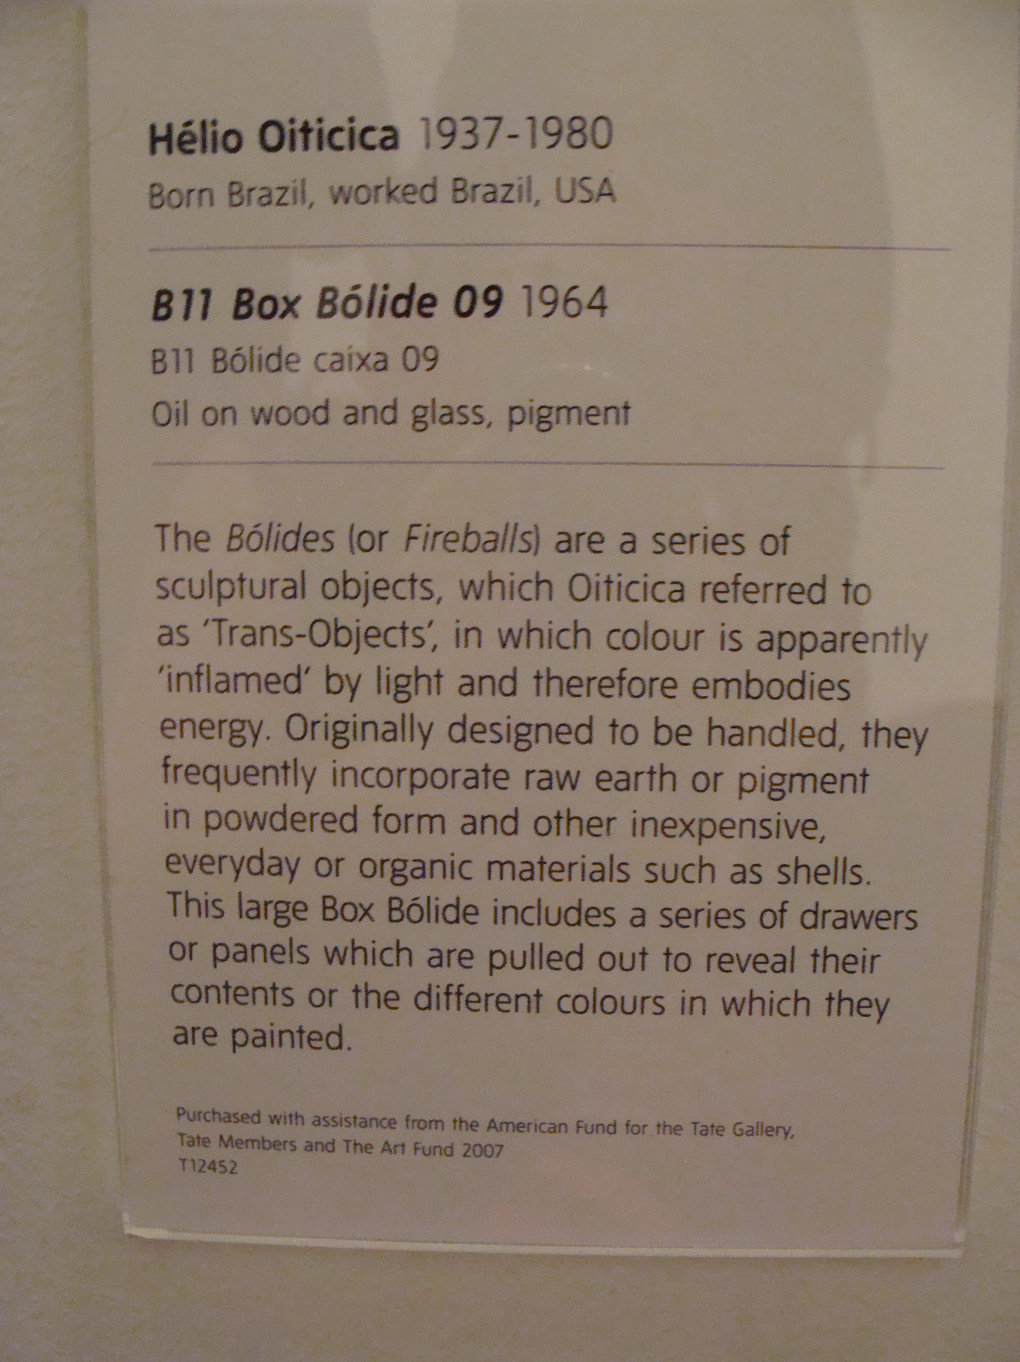

References:
Alexander, M. and Porter, E. (2007-09). Museums in motion: an introduction to the history and functions of museums. Rowman & Littlefield, 2008. ISBN 9780759105096. Retrieved 2009-10-06.

Alvarado, D. and Guerra, T. Hélio Oitica. www.mac.usp.br/mac/templates/projetos/seculoxx/modulo3/neoconcreto/oiticica/index.html accessed on 12/03/2012.

Atkinson, D. Vision and Visuality (Powerpoint used in a lecture of the module Contemporary Arts, Identity and Education). Goldsmiths College, 2012.

Atkinson, D. 2002. Art in Education: Identity and Practice. London: Kluver Academic Publishers.

Balzwich and Morris, 2000. Showing the Twentieth Century. Tate Modern The Hansbook.

Cícero, A. 1995. O mundo desde o fim (The World since the End). Rio de Janeiro: Quase.

Faudez, A. and Freire, P. 1989. Learning to Question: a pedagogy of liberation. Geneva: WCC Publications.

Findlen, P. 1989. "The Museum: its classical etymology and renaissance genealogy". Journal of the History of Collections 1 (1): 59–78. doi:10.1093/jhc/1.1.59 (inactive 2008-06-25). Retrieved 2008-04-05.

Freire, M. 1983. A Paixão de conhecer o mundo. Rio de Janeiro: Paz e Terra.

Freire, P. 1986. Pedagogy of the Opressed. New York: Continuum.

Freire, P. 1992. Extensão ou Comunicação? Rio de janeiro: Paz e Terra.

Gurian, E. 1991. ‘Noodling Around with Exhibitions Opportunities’. In I. Karp and S. Lavine. (eds.) Exhibiting Cultures. 176-190. London: Smithsonian Institution.

Katz, V. 2007. Living Colour. Tate etc. Issue 10 – Summer, pg.79.

McEvilley, T. 1999. Introduction. In O’Doherty, B. Inside the White Cube. London: University of California Press.

O’Doherty, B. 1999. Inside the White Cube. London: University of California Press.
Oiticica, H. 1967. Appearance of the Supra-Sensorial. In Breitwieser, S.Vivencias/Life Experience. 266-269. Generali Foudation.

Oiticica, H. 1968.Tropicália. In Breitwieser, S.Vivencias/Life Experience. 262-265. Generali Foudation.

Oiticica, H. 1968. Apocalipopotesis. http://www.itaucultural.org.br/aplicexternas/enciclopedia/ho/home/dsp_home.cfm accessed on 11/02/2012.

Oiticica, H. 1996. Aspiro ao Grande Labirinto. Rio de Janeiro: Rocco.

Oiticica, H. 1969. The Senses Pointing Towards a New Transformation http://www.itaucultural.org.br/aplicexternas/enciclopedia/ho/home/dsp_home.cfm accessed on 11/02/2012.

Oliver, P. 2010. Foucault – The Keys Ideas: Foucault and institution. http://www.teachyourself.co.uk/subjects/Philosophy-Politics-and-Religion/Foucault-and-institutions.aspx accessed on 03/04/2012.

Osthoff, Simone; Lygia Clark and Hélio Oiticica: A Legacy of Interactivity and Participation for a Telematic Future. http://www.leonardo.info/isast/spec.projects/osthoff/osthoff.html accessed on 31/03/2012.

Ramme, N. Arte como Exercício Experimental da Liberdade (Art as Experimental Exercise of Freedom). http://abrestetica.org.br/deslocamentos/f02.swf accessed on 11/02/2012.

Roiter, C. The Death of Parangolé: Hélio Oiticica and the Problem of Preservation. http://zoolander52.tripod.com/theartsection3.10/id1.html accessed on 05/04/2012.

Simon, N. 2010. The Participatory Museum. http://www.participatorymuseum.org/ accessed on 08/03/2012.

