Looking at myself
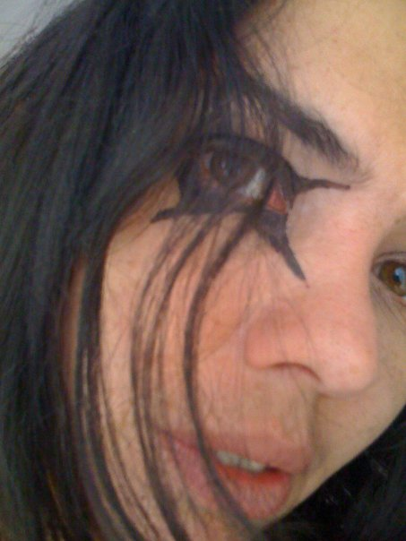
About Myself:

Leave my life in love
Understanding the uncertain of the universe
Craziness and creation are connected
Imagine the infinite: is it incredible or insolent?
Asking about me: Art and Anxiety
Nothing is normal, it is natural
Artist who assumes the action.

If I have to define myself, saying who I am, I promptly answer that I am a woman, (Beauvoir,1973, p. xxi) mother, artist, educator, player, student, researcher, dancer, housewife, I am people that I have met and I am also places where I have been, I am relationality in phenomena. I used to say that my Self is mutant, due to the fact that it is in a constant movement, always in changing, in a process of discovering of the being.
As Buttignol suggests that: “subjectivity is constantly in flux, sometimes it is difficult to know which of my selves is speaking” (Buttignol, In Diamond and Mullen, 2006, pg. 123), I am also among several selves, switching from artist to housewife, from mother to dancer in a fraction of seconds.

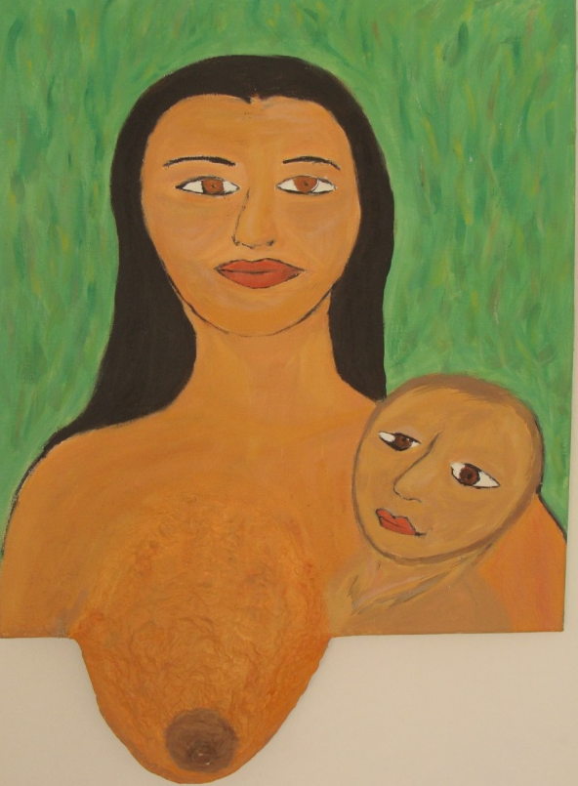
Motherhood:
One of the big change in my life occurred when I became a mother. Before motherhood I was a Marxist revolutionary thinking about changing the world. In being a mother, I understood that the only way to do any revolution in the world, nevertheless in your own world, is through education. Then I encountered Piaget, Vygotsky, Merleau-Ponty and Paulo Freire and since then I started my journey in researching about children development, psychology education and art.
The Mother -acrylic on canvas
Another aspect of the motherhood is the approximation with my mother and the rescuing of my own childhood. At that time, I could understand a little bit more about the circumstances and renounces that be mother signifies. In one of my paintings, The Mother, I painted a woman, with distant eyes and a baby asking for her attention, with a big breast coming out of the canvas, symbolising the feeding. The Madonna has been painted in different styles and occasions, most of the time as a rescue of the anguish of the idealized “Mother”.
According to Winnicott:
“No doubt the baby will be well fed, and he may achieve physical health and growth, but unless his mother can see the human being in the new born infant, there is but a little chance that mental health will be soundly based in such a way that the child in later life can have a rich stable personality that can not only adapt to the world, but also be part of the world which demands adaptation” (Winnicott, 1991, pg.105).
I wish be more than a breast, I wish to be a mother who really assumes her motherhood, being the figure that cares, protects and provides an emotional base for my children, treating and respecting them as individuals.
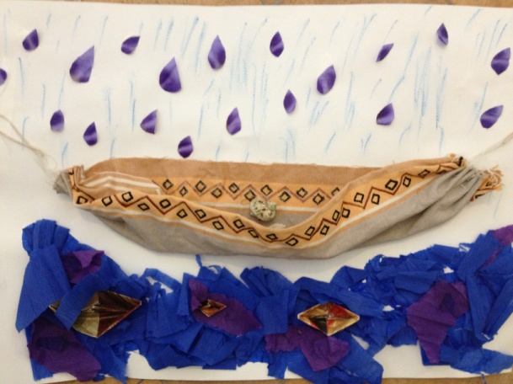
The hammock – fabric, paper, pen and shells on paper
About art, play and Art therapy:
Reality and fantasy often walk side by side in the children’s imaginary and the dialogue between these two worlds, what is real and what is fantastic, is expressed in a symbolic language. From a very early age, play and art are the ways that children communicate with the world and come to an understanding of its possibilities of the reality (Vygotsky, 1978).
Mostly traumas and neurosis in adult life come from the childhood, happening when a child does not have a dedicated mother or when she/he lives in an environment where she/he does not feel protected. Art and play are important forms of symbolize those traumas and deal with the pain. The artistic image emerges as instinct and, instinctively, leads the senses to give shape to sensitivity linked to consciousness. Thus, the art is born of the explosion to feel the deepest sense of existence and transform it into a language.
Art is not as “product of sublimation” (Freud, 1916) leading to neurosis, instead it is a symbolic action leading to an individuation process (Jung, 1970) of existence.
Also, art provides enriching experiences that can help develop our social and emotional skills. Taking into consideration my own experience, the creative process was fundamental to keep my mental health, to deal with my pain and to give me a strong base for the adaptation and relationship with the others and the world.
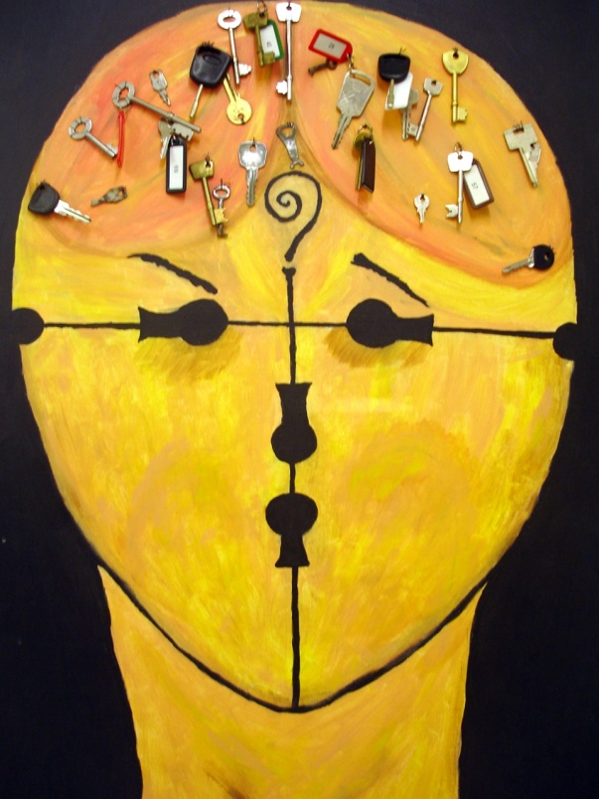
According to Case and Dalfey: “artists are therefore able to recreate their own inner worlds and to give them life in the external world” (Case e Dalfey, 1992 pg.121).
Art is like that: therapeutic, expressive, fantastic, able to taking us to fabulous worlds where we can be ourselves. The action of playing and making art are very important for the development of human beings, remaining a significant means for a person development throughout their lives. Therefore, art is an indispensable element in any educational process, from pre-school infants to post-doctoral research students.
According to philosopher and psychologist Merleau-Ponty, the infantile drawing draws out the infantile perception. It always does not correspond to the reality of the things, but the expression of a character, an attitude (Merleau-Ponty, 2010). The drawing and the painting allow the children to symbolize its dreams, feelings and desires, as well as, supply deeper knowledge of their reality. Perhaps that is the reason why the drawing is the most artistic expression used in art therapy.
Looking for the keys – Acrylic on canvas

Myself as artist teacher:
As an artist educator, I have developed my practice based on the spontaneity of the creation. The imagination and spontaneous action allow the artist to shape vital forces contained in man, and in nature, enabling thus creation.
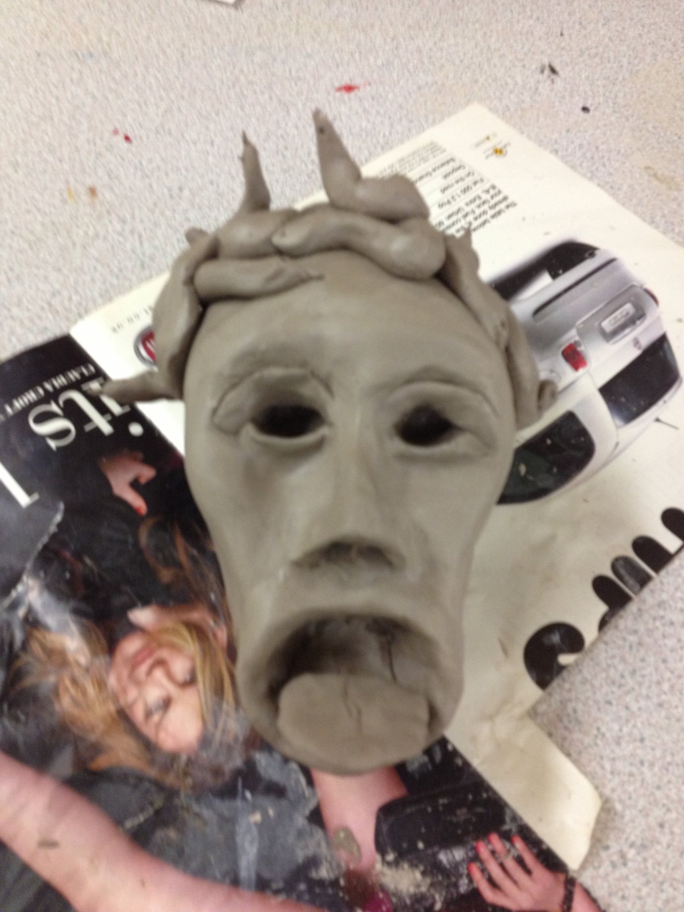
In a different approach to view the learning process, placing it in the child’s reality, or as the philosopher Husserl says, in the plan which the things are given itself in the phenomenon, we invite the children to play and interact, expressing through the art, hearing a pleasant story, participating in a good game, releasing their imagination and creativity, so having the experience of the ‘thing’ in itself, they can express they interiority and symbolize, which is indispensable for the learning and therapeutic process.

The educator:
When we understand that education is dialogue, and as dialogue it is conversation, intercourse of ideas, exchange of thoughts, feelings, emotions, (Freire, 2007) it is necessary that we create space for questioning (Faundez, A and Freire, P). However, it is important to consider that during the questioning process there are no wrong or right questions to be made, whereas there are no wrong or right answers to be given. Thus, it is creating an open space where everyone has freedom to ask and answer questions, that we have accomplished our practice in educating. It is asking questions, taking risks, making mistakes that we can advance in knowledge (Faundez, A).
We, as educators, are in the process to incentive our children to investigate, be curious, go further, having in mind that we are both in the discovering process, searching signification of signifiers (Freire 1992).
I remember one day when I was teaching philosophy for children, underpinned by Matthew Lipman method, which is based on questioning, logical, critical and creative thinking and after reading a chapter from ‘Memorias da Emilia’ of Monteiro Lobato, I said ‘let’s do a reflection about this text’, automatically I asked the children: ‘Does anyone know what a reflection is?’ One child, age 6, immediately answered me: ‘I know it is when something hits and bounces back’. I was very surprised with a so innocent and truly definition of reflection. Then I said “yes, you are right reflection is when something hits and bounces back, so we will read the text, the text will hit our minds, we will think and talk about it so we will bring it back, reflecting about the text”. Since that day we became more and more enthusiastic with the readings and our reflections were day by day hitting more deeply our mind.

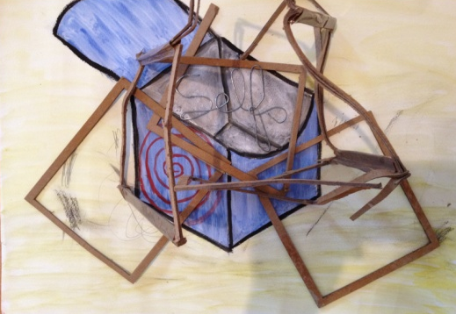
Self – watercolour, wire and cardboard on paper
When I first arrived in England, I could not speak English at all, but how I always worked with children in Brazil, I looked for to continue with my practice as art educator here, so I made a range of toys with recycled materials, which I called “Green Toys”, made some costumes and masks and I started to look for to work with children in my area, Deptford. I went in the local Sure Start, 2000 Community Action Centre, local schools. I showed them the things that I had made, saying more or less like that: I am Luciana, I have done those, I want to work with children, and can you help me, please? They first impression was that: who is this crazy woman? What does she want? I cannot understand her, then they called another Brazilian lady, Dalva, and she translated what I was trying to communicate. Afterwards, I found a very kind and lovely lady that worked for Pepys Community Forum, which believed in my work and gave me the opportunity to run a project with children to lead a series of workshops and create a carnival procession to celebrate the 40th Anniversary of Pepys Estate. Thus, I was introduced to Dalva and together we developed the project. The Costume was designed strongly influenced by the children's own ideas, taking into consideration their countries of origin and their cultural backgrounds. A Group of children that originally was born here created and wore costumes representing the history of Deptford; the remainder of the group wore different costumes, which showed the diversity of Deptford today. The language sometimes creates barriers, when you cannot speak the local language, people see you in a very prejudicial way, thinking that you are ignorant, stupid or dummy. However, with the children was very different. The ‘power of making things’ knocked down the language differences and we used this power to communicate with each other. It was a very interesting situation because, I was there teaching then to making things and they were there teaching me how to speak English, being an exceptional learning experience, real example of exchanging.

Looking at myself
During the module Location and Inter-subjectivity in Art therapy I had the change to take a close look to myself with a dilated pupil. As a process of reflection, I could see and be seen. I could regret, project and express feelings, wishes, traumas and dreams. Experiencing relationships which one I did not have experienced until now. Having the opportunity to look to myself with a reflective eye, look with the eye that is looking to myself is the result of this process.
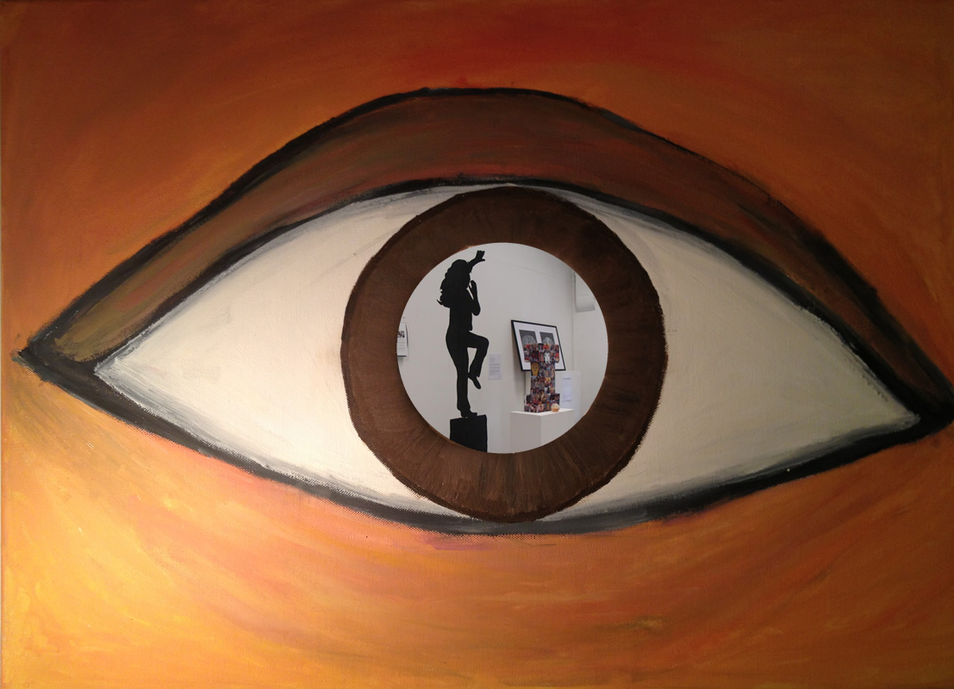
Looking at myself – Acrylic on canvas and film
References:

BEAUVOIR, S. 1973. The Second Sex. New York, Vintage Books.
BITTIGNOL, M. In Diamond, P and Mullen, C, 2006. The postmodern educator: arts-based inquiries and teacher development. California.
CASE, C & DALFEY, T. 1992. The Handbook of Art Therapy
FAUNDEZ, A. and FREIRE, P. 1989. Learning to Question: a pedagogy of liberation. Geneva: WCC Publications.
FREIRE, M. 1983. A Paixão de conhecer o mundo. Rio de Janeiro: Paz e Terra.
FREIRE, P. 1986. Pedagogy of the Opressed. New York: Continuum.
FREIRE, P. 1992. Extensão ou Comunicação? Rio de janeiro: Paz e Terra.
FREUD, S. 1916. Lecture XXIII: The paths to the Formation of Symptoms, in Standard Edition, Vol. XVI. London: The Hogarth Press.
JUNG C.G. 1970. Modern Man in Search of a Soul, London, Routledge & Regan Paul.
MERLEAU-PONTY, M. 2010. Child Psychology and Pedagogy: The Sorbonne Lectures 1949-1952, Northwestern University Press
VYGOTSKY, L. S. 1978 Mind in society. Cambridge, MA: MIT Press.
WINNICOTT, D. W. 1991. The child, the family and the outside world. St Ives, Penguin Books.

